bibliographic Information ツ

Author(s):
N. G. Narayanaswamy and F. Kanehiro,
Title of article or book (if a chapter in a book, put the chapter # and title here, and put the title of the book in “Title of publication”):
IEEE Annual Conference 2024
Title of publication, including Vol., Num., date (if article in magazine, newspaper, or journal):
Vision-Based Software System for Indoor Quadrupedal Locomotion: Integrated with SLAM, Foothold Planning, and Multimodal Gait
Page numbers (if article in magazine, newspaper, or journal):
1330-1335
Publisher:
IEEE
Date published:
2024
URL (if applicable):
https://ieeexplore.ieee.org/abstract/document/10417432
MLA citation:
N. G. Narayanaswamy and F. Kanehiro, "Vision-Based Software System for Indoor Quadrupedal Locomotion: Integrated with SLAM, Foothold Planning, and Multimodal Gait," 2024 IEEE/SICE International Symposium on System Integration (SII), Ha Long, Vietnam, 2024, pp. 1330-1335

Direct quotes: Include Page #s (For each quote, provide some context and/or analysis; you may also want to re-state the information in your own words. Quotes from your sources, and your understanding of them, will make up the bulk of your literature review)
- 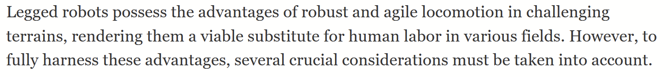p1330
- 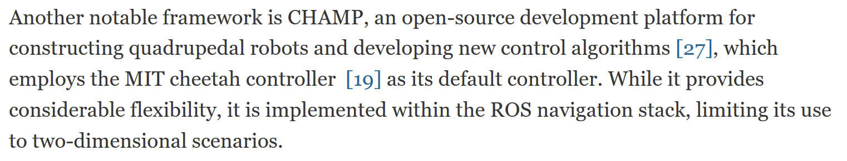p1330
- 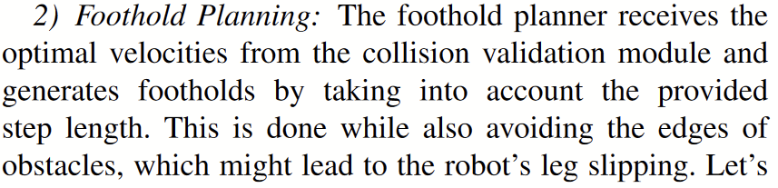p1331
- 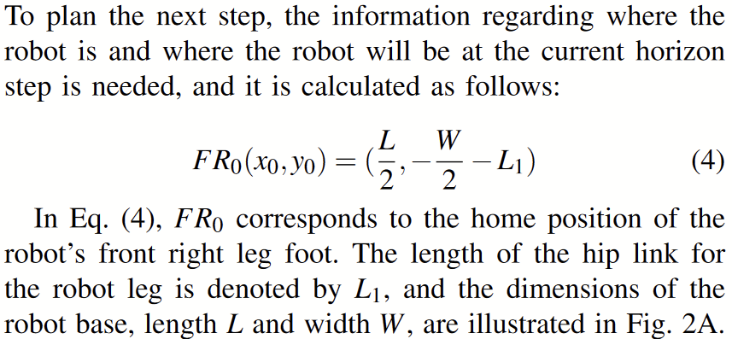p1331
- 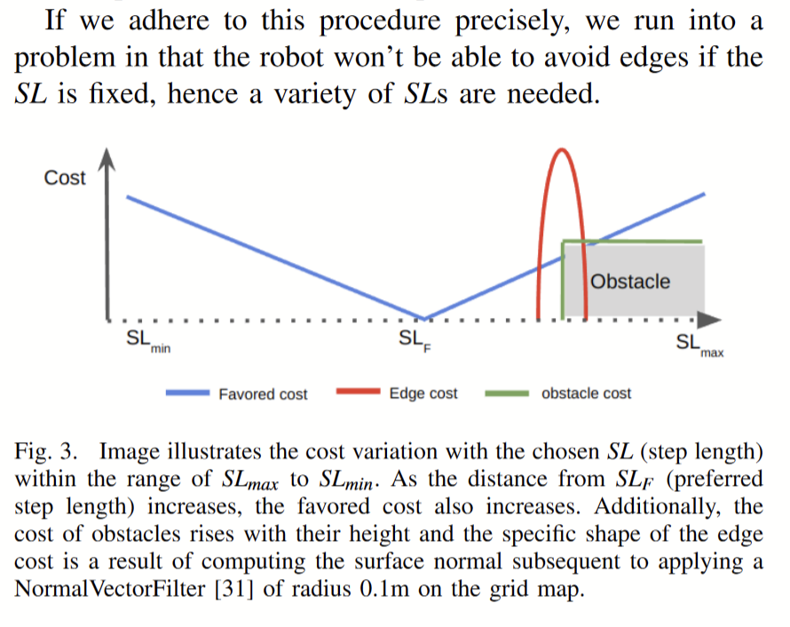p1332
- 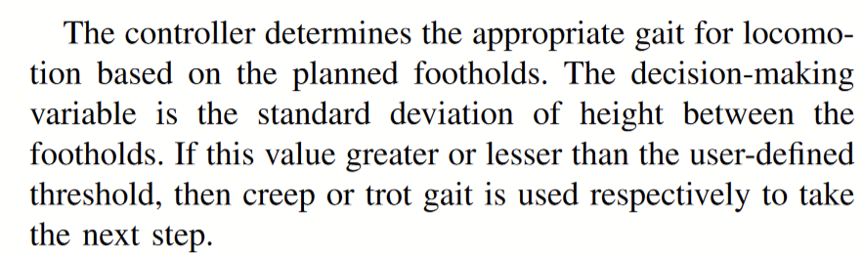p1333
- 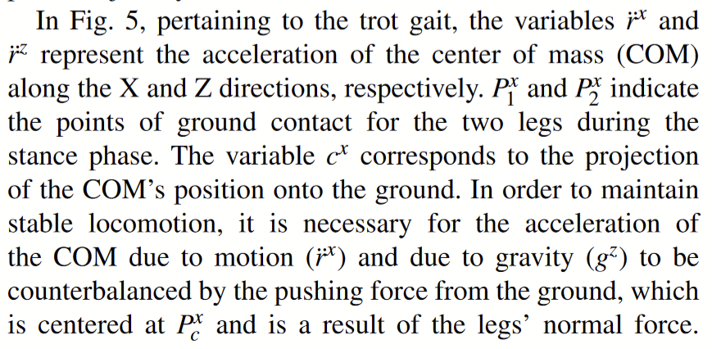
- 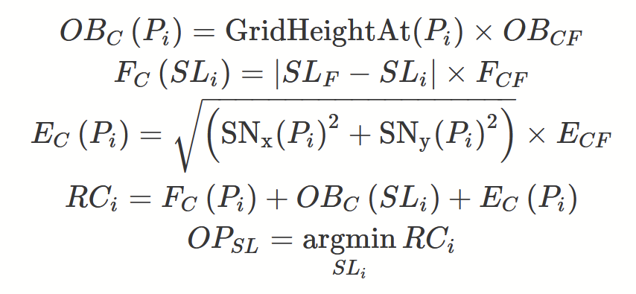

Paraphrased Notes: Include Page #s (This is a space for you to track the flow of information, and the ways in which the article engages with other works.)

Summary of Source (2-4 sentences)
Gait is controlled by taking the range of where the leg could go that could benefit the movement of the robot (going where it wants to go). It takes the min, max, and like 30 other constants of the leg, along with terrain information, and then path plans.

Does this help me answer my question? Why or why not?
Yes, this is literally how they move.

Lingering Questions
Where does this lie in the control scheme? It looks like it could be before or after the planner.

Connections to other sources

